Lab 04 – Worksheet

Name: Romaisa Shazad Myrah Hussain | ID: rb10107  mh10074 | Section:T2

Note: Assumptions and logics should be explained separately in tasks after the task results.

Task 1

Provide appropriately commented codes.
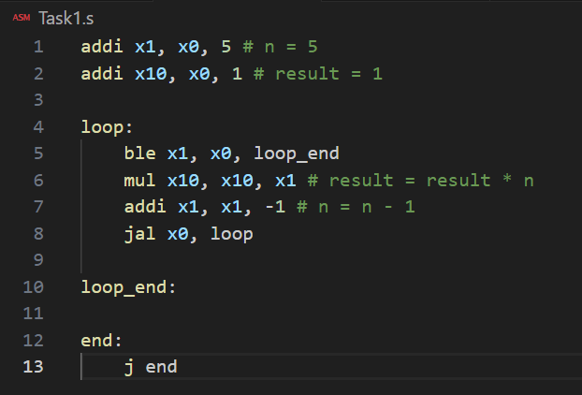

*Add snip of relevant Registers / Memory locations where you think results are obtained. Make sure the irrelevant area of snip is cropped. Make sure the irrelevant area of snip is cropped.
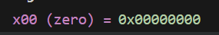
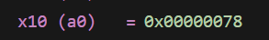

Comments

Task 2

Provide appropriately commented codes
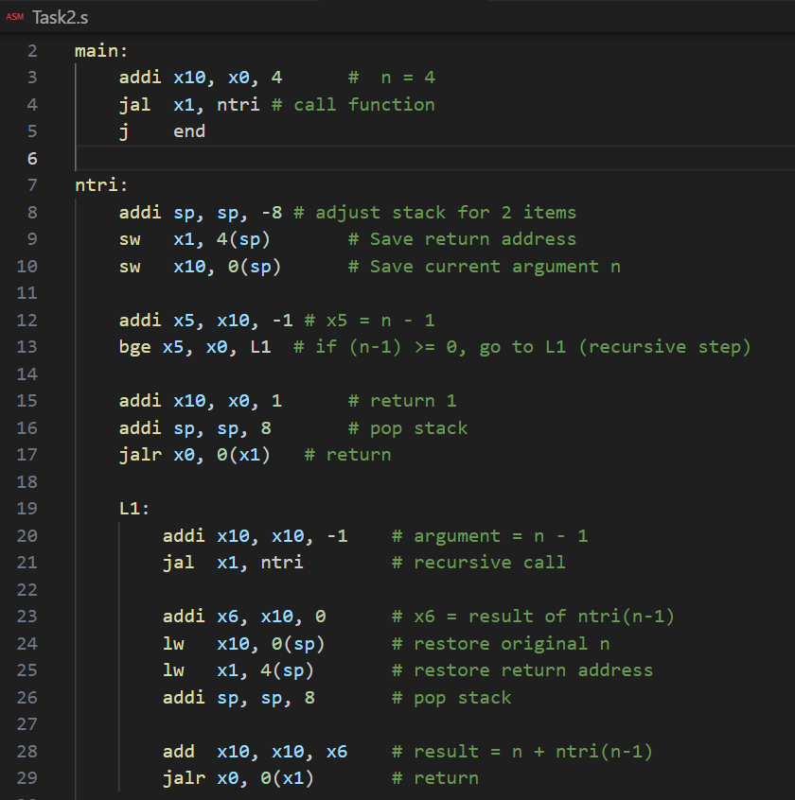
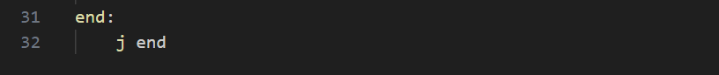

Add screenshot of your results

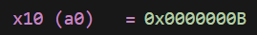

Comments

Task 3

Provide appropriately commented codes
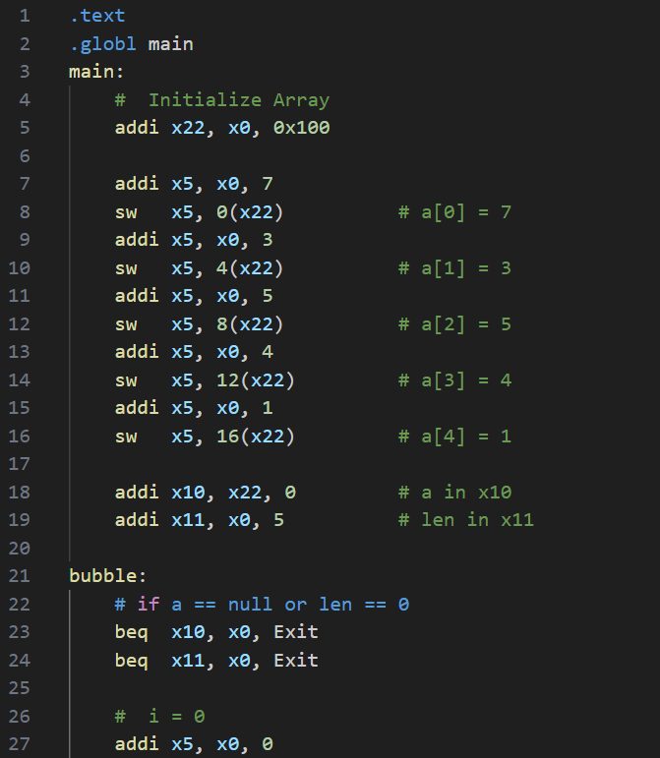
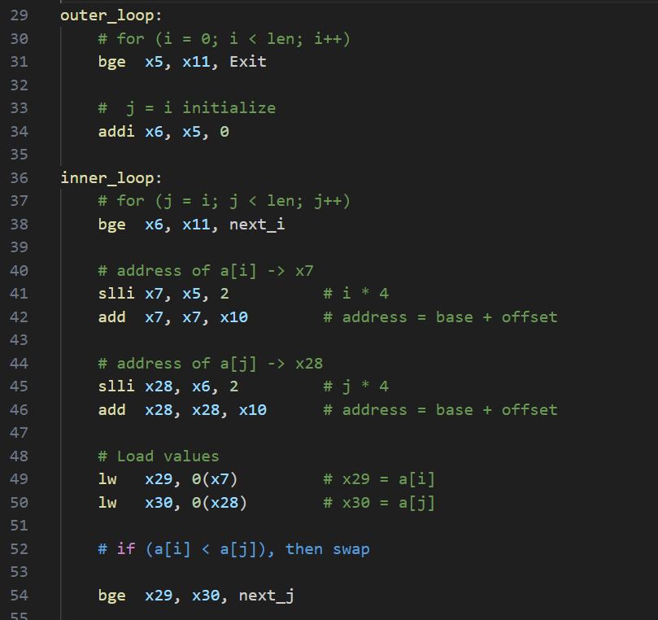
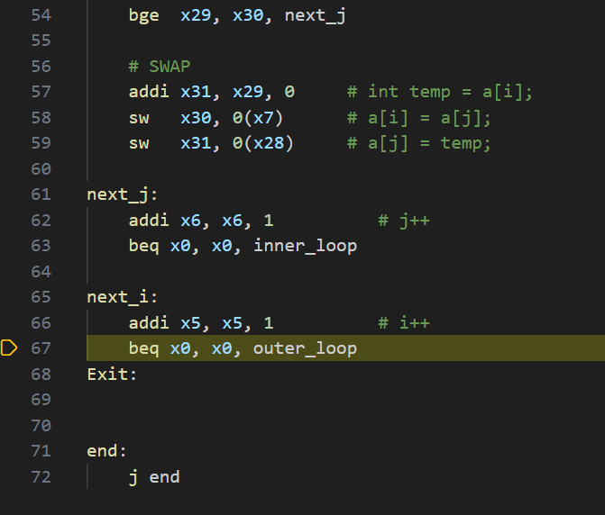

Add screenshots of your results
Before:
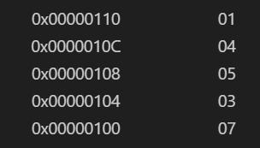

After:

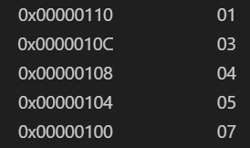

Comments:

Task 4

Provide appropriately commented codes

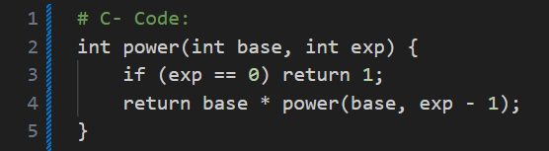

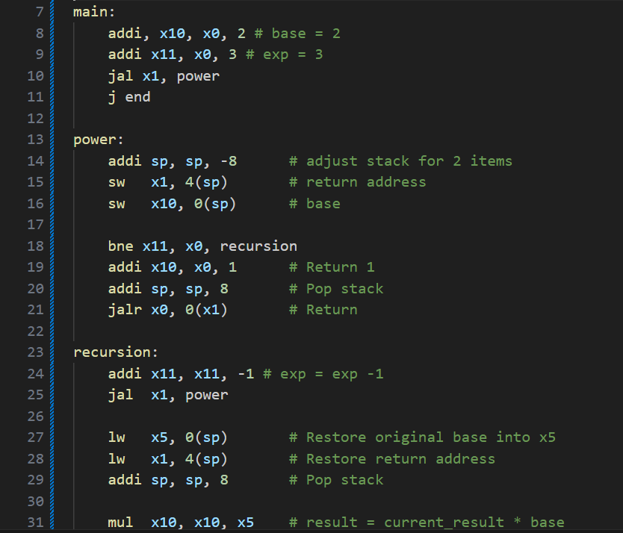
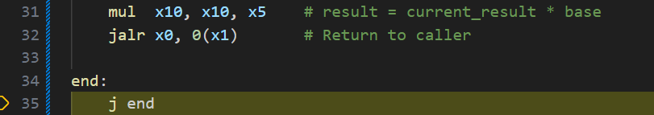

Add screenshots of your results
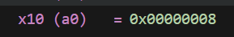

Comments:
2^3 = 2 x 2 x 2 = 8

Lab 04 – Nest Procedures and Sorting

Assessment Rubrics

Points Distribution
Task No. | LR2  Code | LR 5  Results | AR 7  Report Submission & Github
Task 1 | /10 | /05 | /10 & /10
Task 2 | /10 | /10 | /10 & /10
Task 3 | /10 | /10 | /10 & /10
Task 4 | /15 | /10
Total Points | /100 Points
CLO Mapped | CLO 2
For description of different levels of the mapped rubrics, please refer the provided Lab Evaluation Assessment Rubrics and Affective Domain Assessment Rubrics.
# | Assessment Elements | Level 1: Unsatisfactory  Points 0-1 | Level 2: Developing  Points 2 | Level 3:Good  Points 3 | Level 4:Exemplary  Points 4
LR2 | Program/Code/ Simulation Model/ Network Model | Program/code/simulation model/network model does not implement the required functionality and has several errors. The student is not able to utilize even the basic tools of the software. | Program/code/simulation model/network model has some errors and does not produce completely accurate results. Student has limited command on the basic tools of the software. | Program/code/simulation model/network model gives correct output but not efficiently implemented or implemented by computationally complex routine. | Program/code/simulation /network model is efficiently implemented and gives correct output. Student has full command on the basic tools of the software.
LR5 | Results & Plots | Figures/ graphs / tables are not developed or are poorly constructed with erroneous results. Titles, captions, units are not mentioned. Data is presented in an obscure manner. | Figures, graphs and tables are drawn but contain errors. Titles, captions, units are not accurate. Data presentation is not too clear. | All figures, graphs, tables are correctly drawn but contain minor errors or some of the details are missing. | Figures / graphs / tables are correctly drawn and appropriate titles/captions and proper units are mentioned. Data presentation is systematic.
AR9 | Report | All the in-lab tasks are not included in report and / or the report is submitted too late. | Most of the tasks are included in report but are not well explained. All the necessary figures / plots are not included. Report is submitted after due date. | Good summary of most the in-lab tasks is included in report. The work is supported by figures and plots with explanations. The report is submitted timely. | Detailed summary of the in-lab tasks is provided. All tasks are included and explained well. Data is presented clearly including all the necessary figures, plots and tables.

